Management Information Systems, 16E

Laudon & Laudon

Lecture Files by Barbara J. Ellestad

Chapter 3 Information Systems, Organizations, and Strategy

Chapter 3 describes how organizations and information systems work together, or sometimes against each other. The idea, of course, is to keep them in sync, but that’s not always possible. We’ll look at the nature of organizations and how they relate to information systems.

3.1 Which features of organizations do managers need to know about to build and use information systems successfully?

You could say that this chapter relies on the chicken-and-egg theory to develop a relationship between organizations and information systems. You need to design information systems that serve the existing organization. At the same time, you must be ready and willing to restructure the organization to take advantage of the improvements an information system can offer. So, which one takes precedent—the organization or the information system? Actually, neither one. The goal is to adapt one to the other.

What Is an Organization?

An organization is very similar to the information system described in Chapter 1. Remember Figure 1.4 from Chapter 1? Compare it to Figure 3.2 in this chapter.

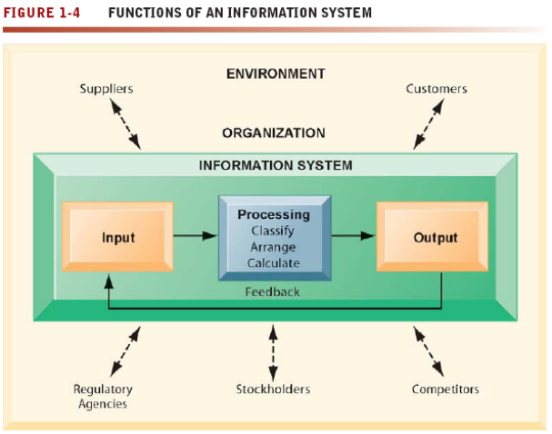

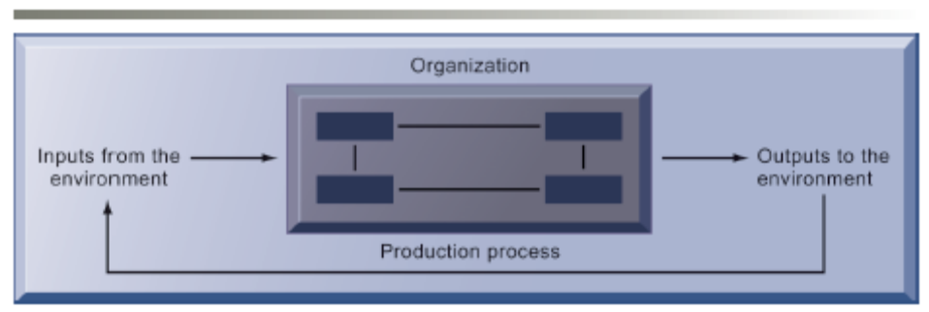

Figure 3.2 The Technical Microeconomic Definition of the Organization

These two figures have many things in common. Both information systems and organizations require inputs and some sort of processing, both have outputs, and both depend on feedback for successful completion of the loop.

Information systems use data as their main ingredient and organizations rely on people. However, the similarities are remarkable. Both utilize a structured method of turning raw products (data/people) into useful entities (information/producers).

Think of some of the organizations in which you’ve been involved. Didn’t each of them have a structure, even if it wasn’t readily apparent? Perhaps the organization seemed chaotic or didn’t seem to have any real purpose. Maybe that was due to poor input, broken-down processing, or unclear output. It could very well be that feedback was ignored or missing altogether.

Many times organizations are turned upside down when new information systems are brought in. It’s not because the system is all wrong for the business. Usually it’s because the system throws the delicate balance of rights, privileges, obligations, responsibilities, and feelings out of kilter. For instance, the marketing department manager used to see all the monthly reports about new customers before any of her employees did. She had a chance to digest the information and formulate responses to questions before disseminating the data to anyone else. After a new information system was integrated throughout the company, all the data regarding new and old customers is available immediately to everyone in the organization. Now, the marketing department manager gets bombarded with questions and comments before she’s even seen the numbers.

Features of Organizations

The class you’re enrolled in is an organization of sorts, isn’t it? Think about it—how many of the following characteristics fit your class? How many fit any organization you’re in?

- Clear division of labor
- Hierarchy of authority
- Abstract rules and procedures
- Impartial judgments
- Technical qualifications for positions
- Maximum organizational efficiency

These characteristics describe organizations that are called bureaucracies, which most of us think of as slow, cumbersome, and unprogressive. That isn’t necessarily so. Many organizations have bureaucratic characteristics and operate very well.

Routines and Business Processes

Successful organizations develop efficient routines for producing goods and services. Successful organizations are able to reduce costs and win a competitive advantage over others because these routines are built into business processes. However, some standard operating procedures (SOPs), politics, and cultures are so ingrained in organizations that they actually hinder the success of the group because they don’t allow people to change their routines and processes as they should.

Organizational Politics

Each person in an organization ultimately has his own goals. Those goals may be aligned very well with organizational goals but perhaps they aren’t. The bottom line is each person comes into an organization with different concerns and perspectives. When those viewpoints clash with others the end result is organizational politics. And, politics can essentially kill organizational changes necessary for incorporating new information systems.

Organizational Culture

Just as every society reflects cultural values such as language, dress, and food, so too does every organization have its own culture. Some companies such as Google are very “laid-back.” The company allows employees to bring their dogs to work and ride skateboards in the hallways. Other companies such as IBM require employees to adhere to a strict dress code and leave the skateboards at home. Yet both companies are very successful in their own right. However, when each company embarks on organizational change, the culture is very much a player in what they can and can’t do.

Organizational Environments

Organizations differ because their ultimate goals differ. Some organizations are small by nature or small by design. Using the same thought process as you did for recognizing the different structures in organizations around you, think about the unique differences in those organizations. Why are they different: size, goals, environmental factors that restrict their growth?

For instance, contrast a real estate company with an insurance company. The real estate company is constantly looking for new customers (buyers and sellers) and new products (houses or commercial properties) to sell. It may choose to stay small or to go with a nationwide conglomerate. The environmental factors that are likely to influence it are the state of the national economy or the nature of the local economy. Many external factors are out of its control. The employees of the company must respond quickly to potential sales or they simply won’t make any money. This type of organization must be creative in the way it generates business and in the type of systems it uses.

On the other hand, the insurance company has relatively stable customers. People sign up with the insurer and pay their premiums on a regular basis. Although customers may come and go, the turnover is fairly small. Because most state governments require people to carry insurance, the agent has a stable stream of income from premiums. Although the parent company may suffer large losses from a sudden influx of customer claims, the small agency is not as heavily influenced by environmental factors. This organization doesn’t have to devise ways of ingeniously using or generating data and its systems needs are mundane.

Both of these businesses are small and entrepreneurial. But they must respond to their employees, customers, and potential customers in very different ways. Each of them has different business processes that must be used to meet goals of staying in business.

Disruptive Technologies: Riding the Wave: Remember typewriters? If you’re younger than the age of 30, you may have never seen one. They were ubiquitous in the business world 40 years ago. How many have you seen lately? Did they fade away because they weren’t a good idea when they were first invented? They weren’t a good product? They didn’t serve a need? As we all know, the answers to all those questions is a resounding no. They were a great invention, a great product, and served a real need. But they were supplanted by a disruptive technology called computers.

There are many examples of how new technologies disrupt old ones in Table 3.1 in the text. How many of the winners and losers do you remember? Companies must continually adapt and change or go out of business. It’s almost that simple.

Organizational Structure

The point is that every group of people is an organization. The interesting question you could ask yourself would be: “How would the world look and function without some kind of organization?”

Table 3.2 shows some common organizational structures. Think about your own experiences, in your workplace or your daily life, and try to list some organizations that fit into each category. They’re all around you and affect you in so many ways. Remember, just as organizations affect you in many different ways, so too do you affect the organizations.

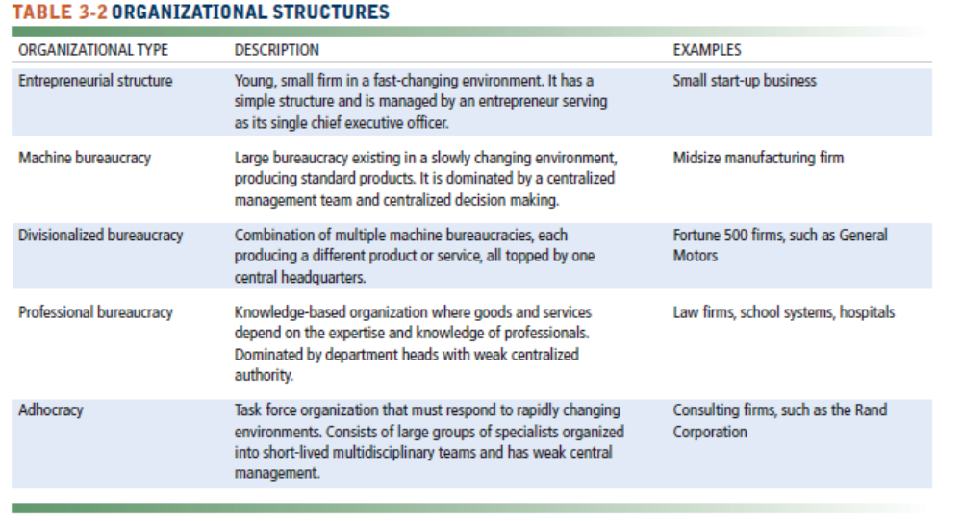

Other Organizational Features

Would you consider the same organizational structure for a softball team as you would for a theatre production group? Although there would be some similarities, the two groups would probably have some major differences. An automobile dealership would have some similarities to a department store (both sell products) and yet they would have major structural differences. Organizations that enter into collaborative partnerships tend to seek out companies with similar structures. It is much easier for the employees to work together if they aren’t required to learn a whole different work structure on top of learning new tasks.

Bottom Line: Organizations and information systems influence each other. Each organization shares common characteristics that an information system can enhance. On the other hand, each organization has unique characteristics that should be taken into account when incorporating technology. The organization should determine how the technology is incorporated and not let the information system totally dictate the organizational structure.

3.2 What is the impact of information systems on organizations?

Change is the only constant in the relationship between information systems and organizations. As technology evolves and changes, its introduction into organizations requires changes in the firm’s infrastructure and the services it can provide to its employees, customers, and suppliers.

Years ago, information systems consisted of a huge mainframe computer with a few terminals connected to it. You had to schedule a specific time to use the computer if your company had one at all. All data were kept on one machine, and in some respects the data were available to whoever could access them.

When personal computers were introduced in the early 1980s, it became the norm for most people to have individual computing islands on their desks. The computers weren’t connected to one another and if you wanted to exchange data or information, you had to somehow get the data from your desk to the other person’s desk. It wasn’t easy.

Now it seems we’ve come full circle in some ways: We’ve combined the storage and data processing on a central machine with personal computing available on stripped-down desktops. The data are available to anyone who can use them or has authorized access through a network with links literally all over the world.

The text discusses two major types of theories about how information systems affect organizations: economic theories and behavioral theories.

Economic Impacts

It’s sometimes cheaper to hire a computer than to hire a person. We may not like the idea that machines can replace human beings, but when you think about it, they have been doing this for thousands of years.

To better illustrate this concept, let’s take a look at how a company can find it cheaper to use an information system to develop and disseminate a human resources policy for employee dress codes. The HR assistant may write the first draft of the policy and give it to the HR director on paper. The director will review it and make changes. The assistant then must incorporate the changes and reprint the document. Wait! If there is an information system, the assistant can submit the draft to the director electronically and the director can make changes to the electronic version of the file and return it to the assistant. Already we’ve saved part of a tree!

Of course, others in the organization must review the new dress code policy. The proposed policy can be printed in 15 copies, a person can manually send the copies out, track who they went to and when, and then track all the changes made to the proposal. Or, the proposed policy can be sent electronically to reviewers who will electronically collaborate on necessary changes. Each of the reviewers can see in “real time” what the others think and the changes they would like to make. We’ve saved another part of the tree in reduced paper use, but we’ve also saved a lot of time and human effort.

Once the policy is set, it has to be sent to each employee. We could do that through the old method of printing hundreds of copies. Or we could send the policy to each person electronically (e-mail). Everyone would have a personal copy stored on computer. There is no need to print it out on paper because it will be stored electronically and can be referenced whenever it is convenient. As employees acknowledge receipt of the policy via e-mail, the HR department knows they received it.

So, what about the people who don’t have their own personal computer? You could post the new policy to the company intranet, which would be available to all employees whenever they find it convenient. Again, time and resources are cut drastically through the use of an information system. If the policy needs to be revised, the same process can be used to make and send out changes. The revised policy can be posted on the intranet for all to see.

This is just one example of how technology is helping organizations reduce their costs of doing business. The transaction cost theory supports the idea that through technology businesses can reduce their costs of processing transactions with the same emphasis and zeal that they try to reduce their production costs.

We mentioned earlier that many of the job cuts taking place in businesses are now affecting white-collar, managerial positions. That follows the agency theory of economic impacts brought on by information systems. Now one manager can oversee ten employees (agents) rather than four employees because information is cheaper and easier to disseminate.

Organizational and Behavioral Impacts

IT Flattens Organizations

Rather than five layers of management in an organization, information technology allows companies to flatten the layers to three, maybe even two. Here’s how:

- IT pushes decision-making rights lower in the organization because lower-level employees receive the information they need to make decisions without supervision.
- Managers now receive so much more accurate information on time, they become much faster at making decisions, so fewer managers are required.
- Management costs decline as a percentage of revenues, and the hierarchy becomes much more efficient.

Postindustrial Organizations

Postindustrial theories also support the notion that IT should flatten hierarchies. Here’s why:

- Professional workers tend to be self-managing, and decision making should become more decentralized as knowledge and information become more widespread throughout the firm.
- IT may encourage task force–networked organizations in which groups of professionals come together—face-to-face or electronically—for short periods of time to accomplish a specific task; once the task is accomplished, the individuals join other task forces.

Technology makes virtual organizations more feasible, cheaper, and easier to set up and tear down than before. If you had a small group of people from each functional area of the company collaborating on a new production method, you can bring them together, decide on the new methodology, and then return them to their regularly assigned units.

Let’s say your company decides to develop a new method of shipping hammers. You would need to draw people from the production department, the shipping department, the packaging department, and the accounting department to help develop the new procedures. Without an information system you would need to have a clerical worker available to record and send out all the information to everyone before and after the meetings. You would have to set up a time and place for team members to meet. Scheduling everyone’s time is often a nightmare! Because of the political nature of organizations and people, which we’ve previously discussed, most of those assigned to this team would probably have to be middle managers.

If your company had the proper information system, much of the hassle and expense of this scenario could be eliminated. By using technology, most of the collaboration and communication throughout the organization, top-to-bottom, side-to-side, could be accomplished quicker and cheaper.

One of the biggest benefits to this method would be the fact that the decision-making process of this committee can be pushed to lower levels and management can check progress electronically. Perhaps the managers wouldn’t be as concerned about delegating responsibility because they can keep an eye on the committee throughout the process and monitor its progress easier. Everyone in the entire organization could have access to the work of the committee. What about those people not physically located in the same place? No problem: Electronically they have the same access to the process as everyone else.

Understanding Organizational Resistance to Change

Information systems are closely intertwined with an organization’s structure, culture, and business processes. New systems disrupt established patterns of work and power relationships, so there is often considerable resistance to them when they are introduced. The complex relationship between information systems, organizational performance, and decision making must be carefully managed.

Technology doesn’t automatically transform organizations. There are no magic wand companies can wave that will solve all their problems just because they installed the latest information system.

People using technology efficiently and effectively, however, can transform organizations. Technology can enhance communications up and down the organization and from one department to another on the same managerial level. As our dress code policy example shows, communications are much faster and better using technology. The lines of communication are shorter, clearer, and more concise.

The behavioral theory of the integration of information systems in an organization says that the political structure of an organization changes through access to information. The common status symbol in an organization used to be the corner office. Now the political status symbol is how much information a person has access to.

The Internet and Organizations

The example used earlier of posting personnel policies to the company intranet is just one small example of how businesses are using network technologies to reduce costs and enhance their business processes. Business-to-business commerce is growing at a tremendous pace because of the cost savings the Internet allows. The Internet provides an open platform technology that allows transaction processing among businesses at much cheaper costs and provides an easy-to-use interface. The innovative ways organizations are using the Internet, intranets, and extranets to improve their business processes and lower costs is simply fascinating.

Even government bureaucracies are getting into the act. The U.S. Post Office is facing a severe threat to its core business. More and more businesses and individuals are turning to e-mail and the web to correspond with one another. As e-mail continues to grow as a substitute for “snail mail,” the Post Office must find innovative ways of using the Internet to gain new business. It’s doing so by selling postage on the Internet, and it now offers electronic bill-paying services. Companies can send bills to their customers electronically and individuals and businesses can pay all their bills over the new Internet-based service.

Implications for the Design and Understanding of Information Systems

The integration of an information system into an organization naturally causes change for the organization. Sounds simple enough. What isn’t so simple to manage is the very fact that many people do not readily accept change. No matter how much technology you employ, it is still the organization’s people who will make or break it. Remember the triangle introduced in Chapter 1, when we discussed hardware, software, and persware? It’s back!

Change can be so traumatic to some organizations that they find it easier to keep doing business the same old way for as long as they can get away with it. That’s why some organizations seem to be stuck doing business the way they did in 1969.

Here are the organizational factors to consider when you’re planning a new system:
- Environment
- Structure
- Culture
- Type and style of leadership
- Principal interest groups affected and attitudes of workers
- Tasks, decisions, and processes that will be affected

Bottom Line: For some jobs, it’s better to employ technology than to employ a person. Technology can reduce costs and increase the amount of information people have access to. The changes brought about by the introduction of new technology and new methods must be managed carefully. No successful manager can lose sight of the effect change will have on the people of the organization. Companies need to tailor their information systems to the needs of the organization instead of letting the wonders of technology drive the organization.

3.3 How do Porter’s competitive forces model, the value chain model, synergies, core competencies, and network economics help companies develop competitive strategies using information systems?

Google, Amazon, eBay—the giants of the Internet. They are successful and make loads of money. They could easily rest on their laurels, kick back, and relax. If they are so successful, why do they keep working so hard to continually introduce new products and services and improve the old ones? Because someone, somewhere, is trying to take their place and become the new giant. These companies must constantly work to keep their competitive advantage and they are using information systems to do so.

Porter’s Competitive Forces Model

Porter’s competitive forces model contends that much of the success or failure of a business depends on its ability to respond to its external environment. Figure 3.8 shows five external forces that every business must contend with at one time or another.

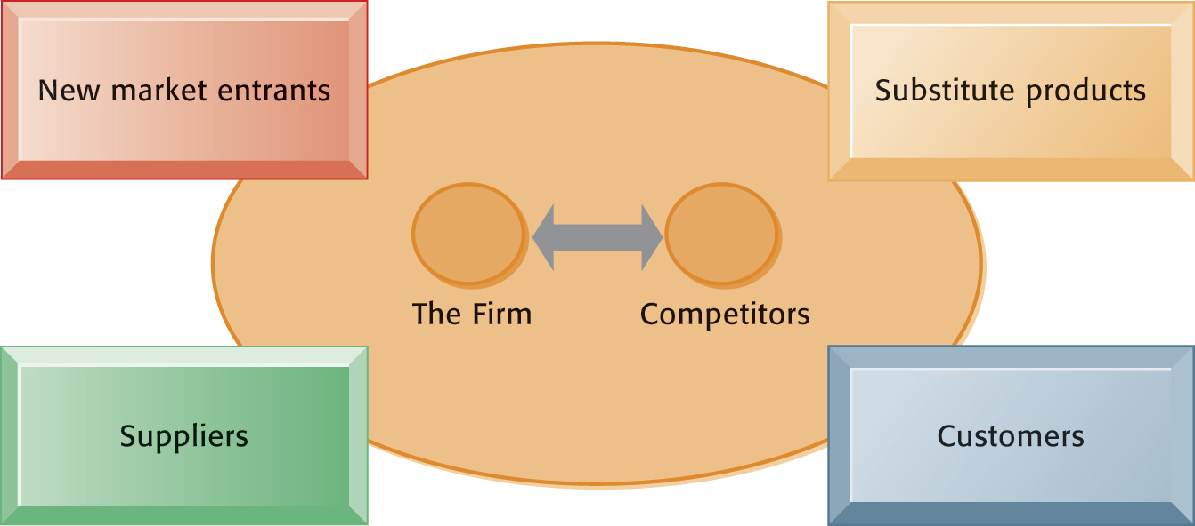

Figure 3.8: Porter’s Competitive Forces Model

It’s important to understand from this model that a firm’s success is not predicated on how well it does internally. It must also pay attention to:

- Traditional competitors: Always nipping at your heals with new products and services trying to steal your customers.
- New market entrants: Not constrained by traditional ways of producing goods and services, they can easily jump into your markets and lure customers away with cheaper or better products and services.
- Substitute products and services: Customers may be willing to try substitute products and services if they decide your price is too high or the quality of your products and services is too low.
- Customers: Fickle to say the least, they are now armed with new information resources that make it easier for them to jump to your competitors, new market entrants, or substitute products.
- Suppliers: The number of suppliers used may determine how easy or difficult your business will have in controlling your supply chain. Too few suppliers and you lose a lot of control.

Information System Strategies for Dealing with Competitive Forces

Many companies have found that effective and efficient information systems allow them to deal with external forces in one of four ways: low-cost leadership, product differentiation, focus on market niche, and strengthen customer and supplier intimacy.

Low-Cost Leadership

By using information systems to lower your operational costs you can lower your prices. That will make it difficult for traditional competitors and new market entrants to match your prices. This strategy works best with commodities such as computers or with household products retailers such as Walmart.

Efficient customer response systems provide a company and its suppliers with an integrated view of customers. These systems provide instantaneous information to the company and its suppliers. Every staff member can have access to the information in the system to help reduce costs and prices well below that of the competition. Processes such as supply replenishment are automated between companies and suppliers. When products reach a certain re-order point, the system automatically sends a message to the supplier who can quickly send out new stock. These systems help companies achieve low-cost leadership in their industry.

Product Differentiation

A very effective use of strategic information systems is to create products or services that are so different that they create barriers for the competition. Product differentiation is at the heart of Apple Computer’s success. Sure, it makes computers. But the company gets away with charging a premium price because it differentiates its products from all others. Competitors, such as Hewlett-Packard and IBM, have tried to duplicate Apple’s strategic business model but have not been quite as successful.

Apple uses product differentiation to help market its iPod and online music system to a broad swath of the population and create barriers that its competitors are having difficulty overcoming.

People like to feel that they are unique individuals with their own needs and desires. One of the best strategies for dealing with competitors is to offer customers exactly what they want, when they want it, and how they want it. The Internet provides a new outlet for mass customization by allowing customers to order one-of-a-kind products.

For instance, by visiting the Ping Golf Club web site, an individual can step through a series of pages that will help design golf clubs personalized to the customer. The customer answers questions on the site about her height, arm length, hand size, and level of play. The site then advises her on the exact type of club that best fits her needs and provides all of the information necessary to order the clubs. Once ordered, Ping can produce the product in a matter of hours and use a shipping partner to deliver the clubs in less than five days. The individual feels special and Ping has gained a new customer.

Interactive Session: Organizations: Digital Technology Helps Crayola Brighten Its Brand (see page 98 in the textbook) explains how the iconic company is reframing its business model to integrate the old and the new and changing the way it markets its products as well as the products themselves.

Focus on Market Niche

If an organization is in a fiercely competitive market, it can choose to focus on a very narrow segment of the market rather than a broad general audience. A firm can gather very specific information about its customers using data mining techniques. Then it creates a focused differentiation business strategy to market directly to those consumers. Being able to address the needs and wants of a very small market segment is why companies are so intent on gathering consumer information from a variety of sources.

Apple Computer uses focused differentiation to help sell its computers to a narrow target market of graphic designers and educators rather than the general population of computer users.

Strengthen Customer and Supplier Intimacy

Supply chain management (SCM) systems increase supplier intimacy whereas customer relationship management systems increase customer intimacy. SCM systems create immense switching costs between a company and its suppliers because of the investment of hardware and software necessary to make the system successful. Customer relationship management systems allow companies to learn details about customers that give them the competitive advantage over traditional competitors and new market entrants.

Implementing these competitive strategies requires precise coordination of people, technology, and the organization. A company can pursue one or more of these strategies but cannot isolate any of the three dimensions of an information system. They must all work in concert together to have any hope of success.

The Internet’s Impact on Competitive Advantage

Try to think of one industry that has not been touched by the Internet. Its impact on Porter’s competitive forces model is apparent from entertainment to retail to travel to financial services. The Internet allows traditional competitors to introduce new products and services and lure customers away. It provides a low-cost avenue for new market entrants. Consumers can easily and quickly find substitute products and services through the Internet. Customers can use information provided on the Internet to create new competition among companies while suppliers can increase their market power. Table 3.5 summarizes the impact the Internet is having on many industries.

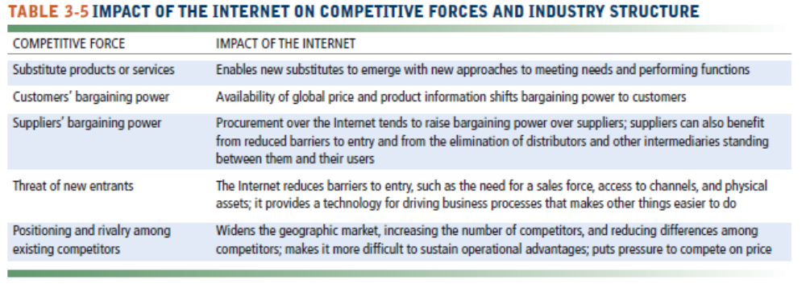

Not all of the news is bad though. The Internet provides new opportunities for companies to increase their customers and markets while reducing their costs. The companies we first mentioned in this section, Google, Amazon, and eBay are continually creating new products and services through the Internet. They are successful because they use their strategic competitive forces information systems to continually improve their competitive advantage.

Of course the Internet has turned many traditional management practices to dust. Customers have access to much more information and data than they ever did before. They can compare product prices across hundreds of companies with a few clicks. Before the Internet, customers may have had access to a limited number of retailers. Through the Internet, they now have access to hundreds of retailers open 24 hours a day. Once, retailers had only local competition. Now they have to compete with other retailers located halfway around the world.

Because of the tremendous growth of the Internet and its influence on all five elements of Porter’s model, businesses must continually monitor the organizational environment, especially the external environment for potential challenges and opportunities. Those businesses that adapt their business model stand a chance of success. Those businesses who ignore the environmental changes and remain stagnant risk everything they have.

Smart Products and the Internet of Things

Think about that gadget you might wear on your wrist the next time you take a walk or run. A lot of data is collected about you and stored on computers owned by the maker of the wearable product. You can keep a history of your exercise and refer to it over time. But if you switch products and purchase a new gadget from a different company, all that data is lost. And that’s exactly why companies are now focusing on ways to keep you from leaving them through high switching costs and product differentiation.

Interactive Session: Technology: Smart Products-Coming Your Way (see page 102 of the text) explains how companies are focusing on information technology to help lock in customers and increase their product differentiation through the use of technology and the Internet.

The Business Value Chain Model

Be better than the competition. That’s the mantra of most companies that are serious about winning the game. Areas of the organization most affected by leveraging technology are in producing the product, getting it to the stores, and making the customer happy. Remember the WorldWide Candy Corporation from Chapter 2? Think of all the activities that go into getting the Cybernuts candy bar made, from procuring raw materials to actual production. Then consider how the candy bar gets from the factory to the store shelves. And what about all those commercials you see?

These are primary activities:
- Inbound logistics
- Operations
- Outbound logistics
- Sales and marketing
- Service

Just as important are support activities:
- Administration and management
- Human resources
- Technology
- Procurement

The value chain model shown in Figure 3.9 will help an organization focus on these activities and determine where to focus their efforts the most.

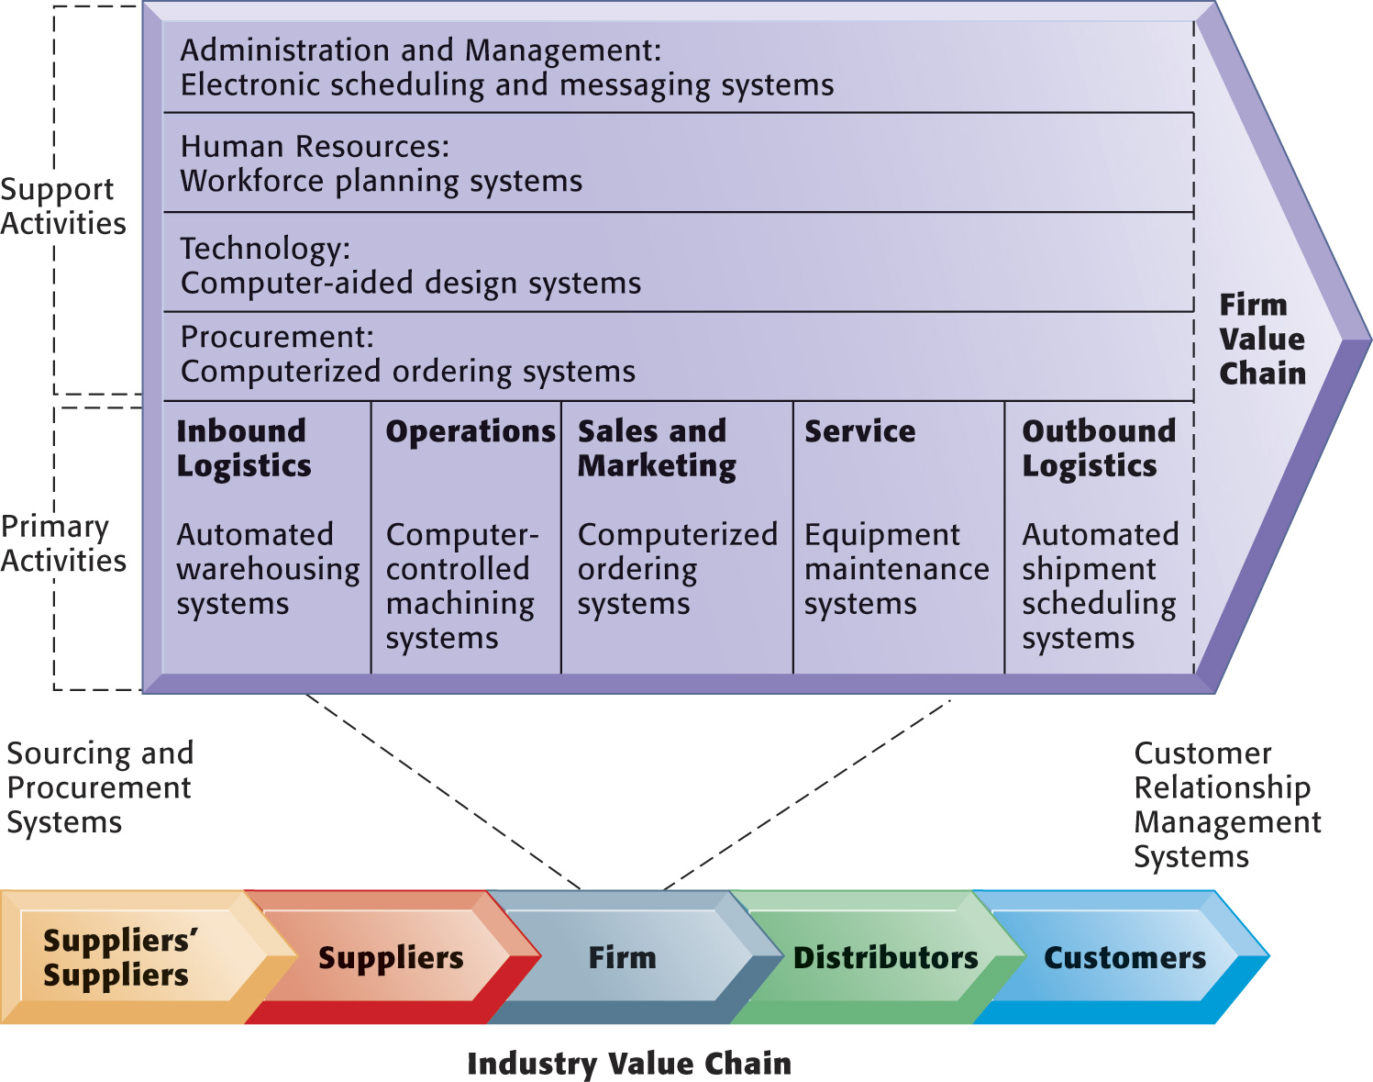

Figure 3.9 The Value Chain Model

By effectively using an information system in a strategic role at any, or preferably all, levels of the organization, a digital firm can provide more value in their products than the competition. If they can’t provide more value, then the strategic information system should help them provide the same value but at a lower price.

Benchmarking provides a way for businesses to determine how they stand up against their competitors within the same industry. For instance, if the industry standard in producing golf clubs is ten days, Ping can benchmark their production schedule of five days and determine that they are more successful than their competitors. They can also research the best practices of other golf club manufacturers and decide if they should fine tune their business processes to wring even more resources from the production process.

Information to formulate benchmarks and best practices can come from internal sources, other companies within the same industry, external industries, university research units, or the government.

Extending the Value Chain: The Value Web

More and more companies are incorporating the Internet in their business strategies through the use of value webs. Ford Motor Company is forming many partnerships and alliances via the web to offer services and products that otherwise would be too difficult, costly, or time-consuming.

“Suppliers are an integral part of our business, and our success is interdependent with theirs. We rely on more than 2,000 production suppliers to provide many of the parts that are assembled into Ford vehicles. Another 9,000 suppliers provide a wide range of nonproduction goods and services, from production equipment to computers to advertising.” (Ford.com web site)

Ford is using value webs to connect with suppliers and business partners and share best practices so that each participant can improve its business processes. That in turn lowers supply costs for Ford and ensures a certain level of standardization through the manufacturing process. Suppliers can collaborate with one another via the value web to enhance their core competencies and improve the entire supply chain. Sharing information through the value web helps not just Ford but the entire vehicle manufacturing industry.

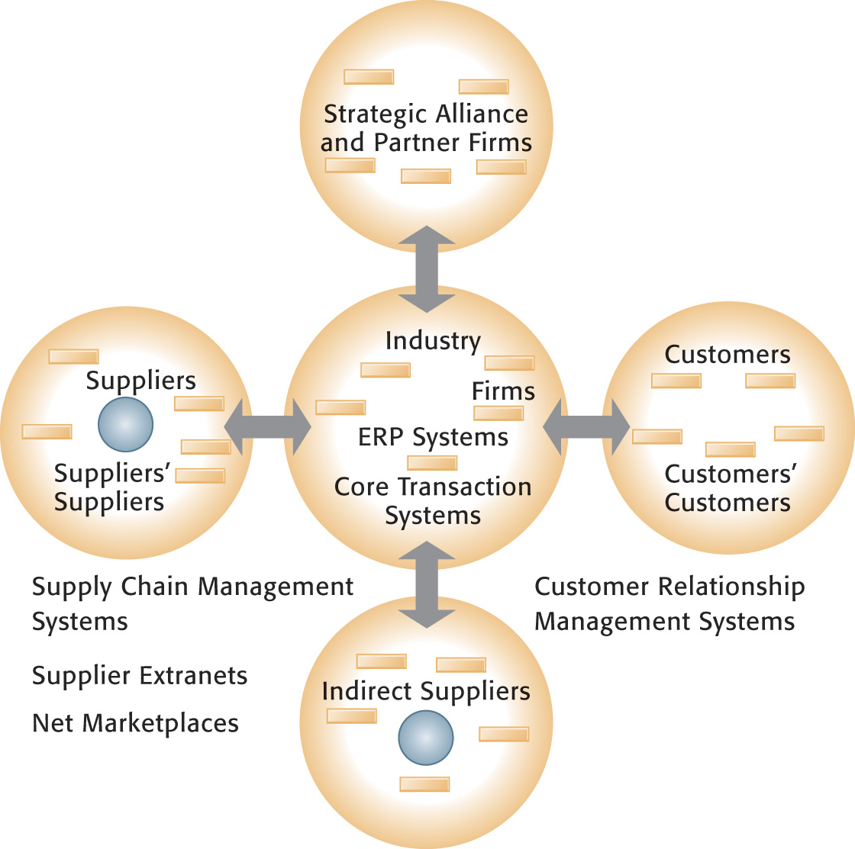

Figure 3.10: The Value Web

Synergies, Core Competencies, and Network-Based Strategies

Very seldom will you find a business that provides all of its own services, supplies, and processes throughout the entire chain. It isn’t practical or efficient to do so. Almost every business relies on partnerships with other companies to produce goods and services. The most successful companies will determine the best synergies, core competencies, and network-based strategies to reduce costs, improve products and services, and increase profits.

Synergies

The news article demonstrates how effective synergy can be. It would be impossible for the television service provider to create content for its customers. It would be impossible for the content creator to build a delivery system to millions of homes. By developing a synergistic relationship between two entities, everyone wins at a much lower cost with better products and services.

New Delhi, Sep 18 (IANS) BIG CBS Networks has announced a tie-up with direct-to-home (DTH) service provider Reliance BIG TV for distribution of their three new English entertainment channels. BIG CBS Networks is a joint venture between the Reliance Broadcast Network and US-based CBS Studios International. The new channels, being launched by the Anil Dhirubhai Ambani Group (ADAG), are BIG CBS Prime, BIG CBS Spark and BIG CBS Love.
“With a reach of around 30 lakh (3 million) digital television homes across India and cashing-in on group synergy, BIG TV was one of the most desirous and natural choices for BIG CBS. Our endeavour is to reach the exclusive and best-in-line content of BIG CBS to maximum relevant audiences across the country and this partnership marks the beginning,” Ashutosh, chief operating officer of BIG Broadcasting, said in a press release Friday.
The three channels will provide a variety of programmes. The target audience of BIG CBS Spark is youths, while BIG CBS Love will aim at women, and BIG CBS Prime will be a complete entertainment channel.
“Our partnership with BIG CBS brings great value to our viewers. It is backed with world-class entertainment content expertise generating top rated programmes consistently. The three BIG CBS channels will offer an envious programme line-up, with some of the flagship shows being telecast in India almost concurrent to that of the US,” said Sanjay Behl, chief executive officer of Reliance DTH and IPTV. (www.thaindian.com/newsportal, September 18, 2010)

Enhancing Core Competencies

Why did Ford Motor Company form an alliance with UPS instead of continuing its long-time practice of delivering vehicles to dealers itself? Because Ford wanted to concentrate on its core competency of manufacturing vehicles and let UPS concentrate on its core competency of delivering products.
UPSLogistics’ web site says “By shaving four days off the delivery cycle and reengineering the network, Ford is realizing a $1 billion dollar reduction in vehicle inventory and more than $125 million in inventory carrying-cost reductions on an annualized basis. ‘The savings will continue to grow as our precision, web-enabled system reaches maturity and we surface and eliminate more non-value-added activities,’ said Taylor. Ford and UPS Logistics Group launched the alliance a year ago to reengineer Ford’s vehicle delivery system amid rising consumer demand for on-time vehicle delivery. UPS Logistics Group created UPS Autogistics as a business unit to manage the project. ‘With a single network manager in place to analyze any potential problems before they occur, we’ve managed to avoid bottlenecks, reduce the amount of assets in the supply chain, and cut inventory carrying costs,’ said Tom Kolakowski, manager of Ford North American Vehicle Logistics.”

Network-Based Strategies

It’s long been known in the economics field that the economics of manufacturing produces a diminishing return on investment at some point in time. But in network economics the opposite is true.

For example, you have a small company with 15 employees operating on a client/server network. You’ve already paid for the server that supports 25 employees. When you hire the 16th employee, you won’t have to spend much money, if any, to support the new employee on the network. You’re actually increasing the server’s output without an associated increase in cost.

Technology makes virtual companies more feasible, cheaper, and easier to set up and tear down than before. Let’s say you own a small company in northern Arizona that offers white-water rafting trips through the Grand Canyon. You have a fleet of rafts and 35 full-time employees. Rather than you trying to manage the payroll and benefits program for your employees you could use a company that specializes in payroll, employee benefit programs, and even retirement plans. Intuit, who manufactures Quicken and QuickBooks, provides an online service for businesses that does all of these things. You access Intuit’s web site, enter the necessary data, and it takes care of the rest of the processes, even down to filing the government tax forms. You concentrate on your rafting business instead.

The Boeing Company, manufacturer of airplanes, uses virtual organizations throughout its design and manufacturing processes. It contracts with other businesses for certain types of work such as the development of new seat configurations. When the process is completed, the outside vendor is released from the job.

As more companies outsource work to other vendors, virtual organizations are becoming the norm. Network technologies based on Internet standards provide the infrastructure necessary to make them successful. Companies are no longer tied to suppliers and business partners located in specific geographical areas but can find the best service provider or business partner around the world.

Porter’s competitive forces model is predicated on traditional structures in separated industries. That is, one company built a product including content. When IBM built its first mainframe computer, not only did it handle all the hardware design and manufacture it also supplied all the software programs to go with it. Apple did basically the same with its first personal computers. But all that is changing rapidly based on business ecosystems.

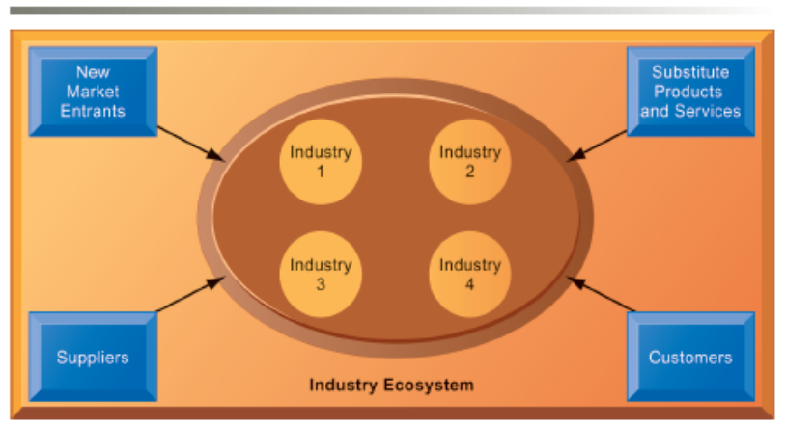

Figure 3.11 An Ecosystem Strategic Model

Think smartphones and apps. In this business ecosystem, one company builds a smartphone—Motorola and its RAZR phone. Another company, Verizon Wireless, helps market and sell the phone to promote its cell phone services. Other companies supply more than 200,000 apps that consumers can purchase to extend the functionality of both the phone and the wireless service. Internet service providers also belong to this business ecosystem in order to extend their data services to customers. None of these businesses could possibly supply all four elements of the ecosystem.

Rather these businesses combine their expertise into one value web and create a platform on which other companies build their products and services. Microsoft and Facebook are the two most familiar platforms used by thousands of companies and individuals.

An ecosystem most familiar to us all is the mobile Internet platform that consists of four industries: device makers, wireless telecommunication firms, independent software applications providers, and Internet service providers.

Bottom Line: Using information systems can help a company beat the competition through differentiation and through providing services that are valuable to both customers and suppliers. Companies can also use information systems to reduce costs. Information technology is also challenging the traditional concepts of competition and partnerships that have existed for years.

3.4 What are the challenges posed by strategic information systems and how should they be addressed?

Strategic information systems often change the organization as well as its products, services, and operating procedures, driving the organization into new behavioral patterns. Successfully using information systems to achieve a competitive advantage is challenging and requires precise coordination of technology, organizations, and management.

Sustaining Competitive Advantage

Using information systems to beat the competition and increase the value of a product is not easy. Because competitors can quickly copy strategic systems, competitive advantage is not always sustainable. Sustaining a competitive advantage constantly requires changing processes and methods of conducting business. Managers simply cannot rest on their laurels with today’s fast paced, fast changing technological advances. Technology changes much faster than organizations can adapt. As soon as employees and managers become comfortable with a particular system, it’s almost time to make some more changes.

Aligning IT with Business Objectives

It’s such a basic idea—an organization should align its information technology with its business objectives. Yet, too many times it seems that a firm’s IT is actually working against the rest of the business. It’s an easy thing to have happen when the techies and the nontechies fail to work together to plan, implement, and maintain information systems that support their company’s business objectives and competitive strategy.

Employees and managers in all the functional areas must be active players in the IT game. They can’t sit on the sidelines and let someone else decide what kind of information system the company will have. They can’t claim ignorance and say they don’t know that much about computers. They cannot shed their responsibility and then lay the blame for a flawed or failed system at someone else’s doorstep.

Management Checklist: Performing a Strategic Systems Analysis

Completing a strategic systems analysis is one of the first steps managers should take to help determine how they can use information systems to gain a competitive advantage. Ask yourself these questions about your own firm:

- What is the structure of the industry in which your firm is located?
- What are the business, firm, and industry value chains for your firm?
- Have you aligned IT with your business strategy and goals?

Managing Strategic Transitions

A vital attribute of any manager’s success is the ability to adapt to change. The pace of technological change is at its highest level ever. With each advance, the organization must use strategic transitions, a movement among levels of sociotechnical systems, to its advantage. Making changes in the information systems should trigger a review of associated processes to make sure they are in sync. Teaming up with competitors may seem at odds with wanting to beat the competition, but in fact may be the smartest thing to do. Technological changes allow you to do both without sacrificing too much.

As we continue through the book, you should keep in mind how organizations are structured, how information needs vary from one organization to another, and how information systems can enhance or detract the characteristics of an organization. The most important thing you should remember is that at the core of every organization are people.

Bottom Line: A well-developed strategic information system that is integrated throughout the company can be used to lower overall costs and provide greater value to the company, the supplier, and the customer.

3.5 How will MIS help my career?

The chapter’s elements and information can help in securing a good job as an entry-level business development representative. This position will help the company’s sales team meet aggressive growth targets. These types of jobs are becoming more popular as information technology becomes more important in the workplace.

Discussion Questions
- Discuss the impact new information systems may have on organizational culture and organizational politics.
- Describe the difference between the economic theory and the behavioral theory of how information systems affect organizations.
- Discuss how business ecosystems can extend a company’s products and services and increase its competitive advantage. Give an example of a business ecosystem for a product or service that you are using.
- How can managers’ roles be enhanced with a well-integrated information system? How can their roles be diminished with a poorly-integrated information system?

5. Ask yourself these questions about your own firm:
a. Describe the structure of the industry in which your firm is located?
b. Describe the business, firm, and industry value chains for your firm
c. Describe how your firm aligned its IT with its business strategy and goals?

Answers to Discussion Questions

- Political resistance is one of the great difficulties of bringing about organization change—especially the development of new information systems. Employees have different viewpoints about how resources, rewards, and punishments should be distributed and information systems can bring about significant changes in strategy, business objectives, business processes, and procedures. Organizational culture encompasses a basic set of assumptions about what products to produce, how to produce them, where, and for whom. Because technological changes can disrupt these basic assumptions, organizational culture is severely threatened. Therefore, employees will resist the changes.
- The answer should discuss the economic theory benefits of information systems and how they allow companies to replace humans with machines, reduce transaction costs, and reduce internal management costs. Behavioral theory references should include the ability to push decision making to lower levels because of increased access to information and to have a larger number of employees per manager. The effect on organizational politics because of wider access to information resources is an important part of the answer.
- Business ecosystems allow companies to concentrate on their core competencies while teaming with other businesses to extend products and services that they wouldn’t be able to do on their own. The best example of a business ecosystem is the smartphone and cellular services industries.
- Answers should include information about the increased number of people the manager can easily and effectively communicate with. By giving the manager timely and complete access to information from all parts of the organization, a company can enhance the decision-making process for its managers because the decisions are based on as much information and data as possible. Cumbersome, poorly-integrated information systems can deny the manager valuable information and lead to bad decisions based on bad information.
- Answers will vary depending on the student’s particular situation but should include information from throughout the chapter and rely on the subquestions in Section 3.4 of the text.

